**Experiment-10**

**Aim:** Design a two-stage operational amplifier with the first stage as a differential amplifier with active load for a gain of 30V/V and the second stage as a CS Amplifier with a gain of 20V/V. Assume I SS =0.1mA, V GS =0.7V, Vth =0.4V and consider suitable technology parameters values.

1. Compare the result with LTSPICE Simulation.
2. Perform the transient analysis of the same.

**Apparatus required:** LTSpice Software.

**Circuit:**

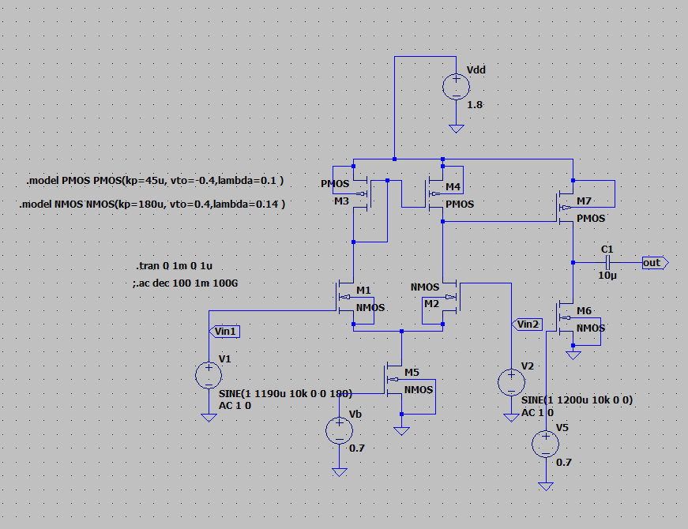

Transfer Function:

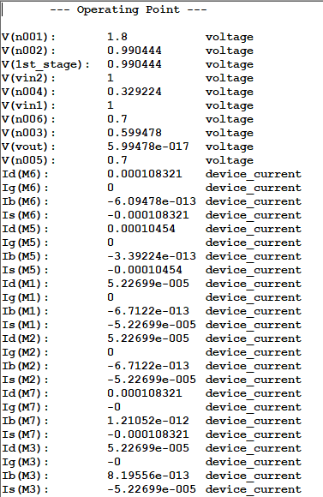

Output:

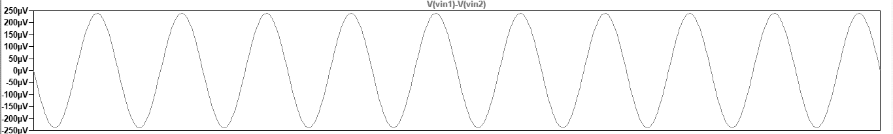

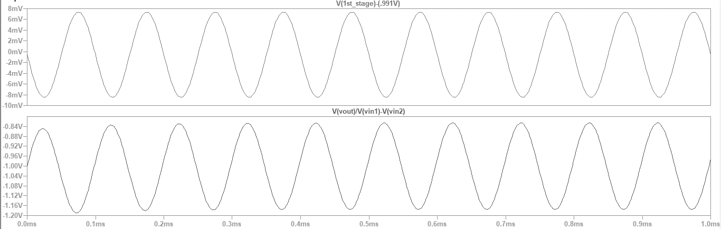

Result:

The two-stage operational amplifier with the first stage as a differential amplifier with an active load is implemented and the gain of 600 V/V is Obtained.